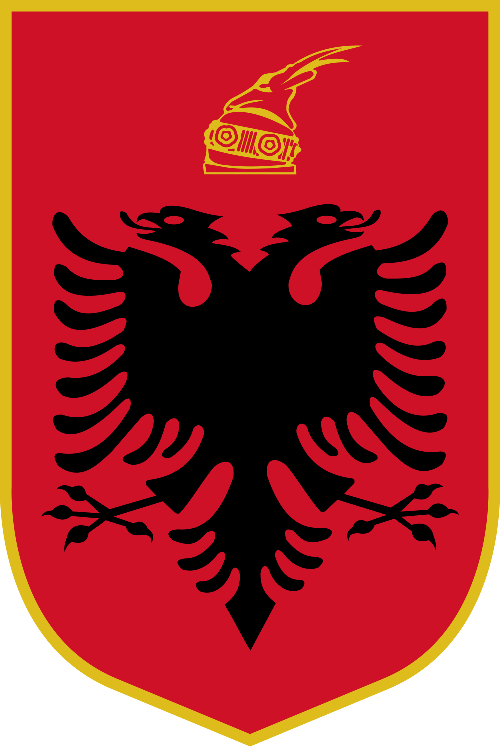
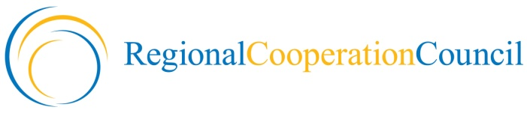

MINISTERIAL CONFERENCE OF THE
SOUTH EAST EUROPE INVESTMENT COMMITTEE

“South East Europe 2020 –
Towards Convergence and Growth”

Co-organized by the
Regional Cooperation Council and the Republic of Albania

9 November 2012
Tirana, Republic of Albania

Ministerial Conference
Of The South East Europe Investment Committee (SEEIC)
“South East Europe 2020 – Towards Convergence and Growth”

Tirana, 8-9 November 2012

Thursday, 8 November, 2012
Venue: Sofra Ariut Restaurant Tirana

20:00 Official dinner hosted by the Government of the Republic of Albania
“Sofra Ariut“ Restaurant, Tirana

Friday, 9 November, 2012
Venue: Hotel Tirana International

09.30 – 10.00 Opening Remarks
- H.E. Edmond Haxhinasto, Deputy Prime Minister and Minister of Economy, Trade and Energy of the Republic of Albania,
- H.E. Hido Biscevic, Secretary General, Regional Cooperation Council

10:00 – 10:20 Keynote Speech by the European Union Representative
- H.E. Ambassador Ettore Sequi, Head of Delegation, Delegation of the European Union to Albania

10:20 – 11:30 Addresses by the Ministers and Other Participating Dignitaries
- Ministers and Heads of Delegations of the SEEIC Economies
- Other Heads of Delegations and Participating Dignitaries

11:30 – 11:45 Adoption of the Ministerial Declaration
- Adoption of the SEE 2020 Targets

11:45 - 12:00 Family Photo

12:00 – 12:30 Joint Press Conference
- Attended by SEEIC Heads of Delegations

12:30 – 14:00 Lunch hosted by the Regional Cooperation Council

14:00 Departure of Delegations

